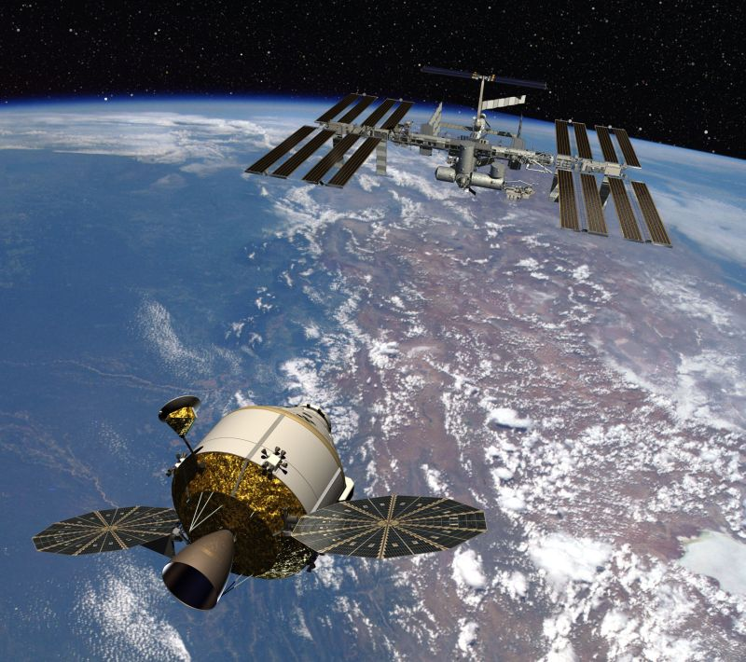
AIAA Houston Section
Annual Technical Symposium
ATS 2008
NASA/JSC Gilruth Center
Houston, Texas
Friday, May 9, 2008
PROGRAM

General Chair | Organizing Committee
Sean Carter/Mantech SRS | Norm Chaffee/NASA (retired)  Amy Efting/Gary Cowan(BAH)  Ludmila Dmitriev-Odier/USA  Brian Dunaway/Boeing  Ellen Gillespie/USA  BeBe Kelly-Serrato/Consultant,4Frontiers

Contents
Contents 2
Program Summary 4
Symposium Location 5
Symposium Information 7
Registration 7
Special Events 7
Technical Program 9
Technical Sessions 9
Presentations 9
Keynote Speaker Biographies 10
Technical Session Abstracts 13

Thanks to our 2008 corporate sponsors







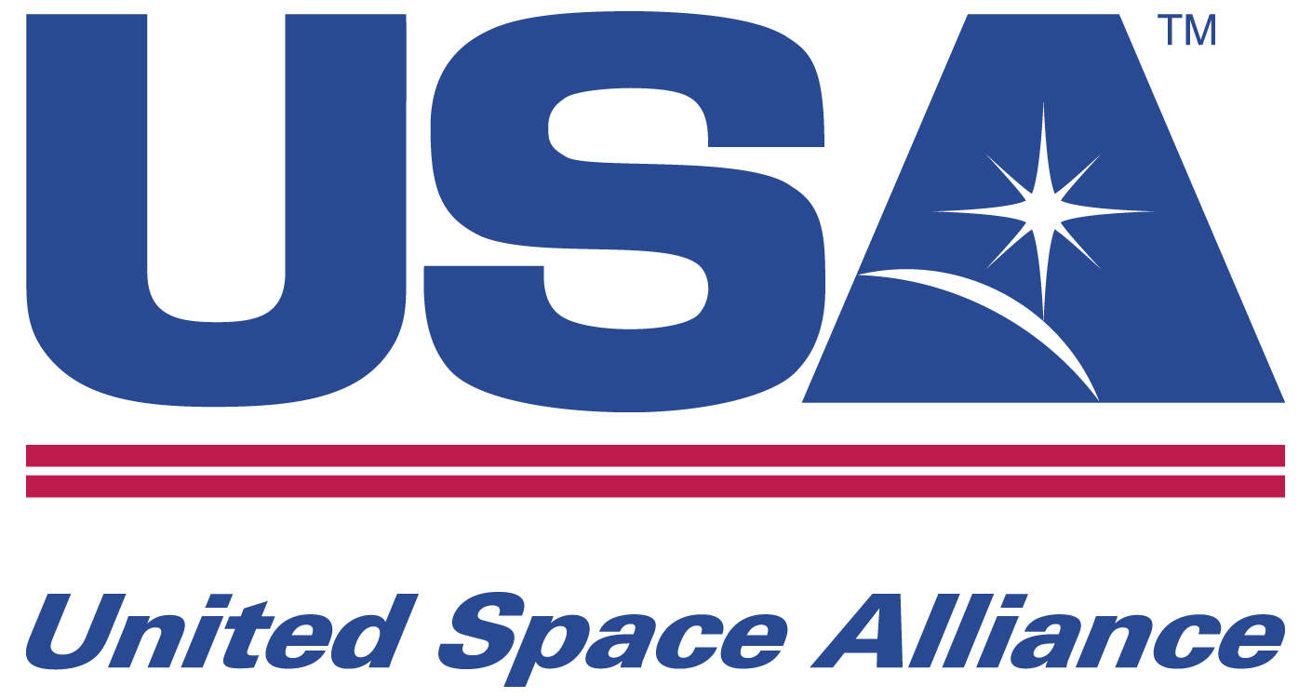

Program Summary
Time | Event | Location
7:45 AM – 4:30 PM | Registration Desk on First Floor | Next to Alamo Room
8:15 AM - 8:45 AM | Wayne Hale:  “Shuttle/Station Schedule: Transition Plan to Constellation” | Alamo Ballroom
9:00 AM – 10:00 AM | Robert Hampton: “ISS Lessons Learned: 2nd Order Effects” | Alamo Ballroom  Session Chair: Gary Brown
9:00 AM – 10:00 AM | Scott Nemeth: “Hybrid simulation technology: The next step in the evolution of spaceflight simulations” | Lone Star Room  Session Chair: Dan Brockway
9:00 AM – 10:00 AM | Steve Rader: “Constellation’s Command, Control, Communication & Information Architecture Overview” | Longhorn Room  Session Chair: Cindy Kurt
10:00 AM – 11:00 AM | Heather M. Rodriguez: “Orbital Debris: Past, Present, and Future” | Alamo Ballroom  Session Chair: Steve King
10:00 AM – 11:00 AM | Eduardo Garcia-Llama: “Attitude Determination for Emergency Atmospheric Entry with 3-Axis Accelerometer” | Lone Star Room  Session Chair: Dan Brockway
10:00 AM – 11:00 AM | Chris Ramsay: “Software Safety” | Longhorn Room  Session Chair: Shirley Brandt
11:00 AM – 12:00 PM | Bill Bastedo: “ISS Lessons Learned: Getting Node 1 Ready to Fly” | Alamo Ballroom  Session Chair: Gary Brown
11:00 AM – 12:00 PM | Lesley A. Weitz: “The development of an autonomous robotic team for space habitat construction” | Lone Star Room  Session Chair: Shirley Brandt
11:00 AM – 12:00 PM | Dan Deans: “Design for Reliability and Maintainability” | Longhorn Room  Session Chair: Cindy Kurt
12:00 PM – 12:45 PM | Lunch | Alamo Ballroom
12:45 PM – 1:15 PM  1:15 PM – 1:45 PM | Clint Dorris: “Constellation’s ALTAIR Lunar Lander”  Chris Culbert: “Concepts for Building a Base on the Moon” | Alamo Ballroom
2:00 PM – 3:00 PM | Steve King: “Overview of Orion CEV Mechanisms” | Alamo Ballroom  Session Chair: Sean Carter
3:00 PM – 4:00 PM | Dr. Jared Squire: “VASIMR: Future Propulsion Technology” ,Mr. Tim Glover Lunar Access with VASIMR | Alamo Ballroom  Session Chair: Sean Carter

Symposium Location

The American Institute of Aeronautics and Astronautics (AIAA), Houston Section, welcomes you to the 2008 Annual Technical Symposium at NASA/JSC Gilruth Center on May 9, 2008.

Enter Gilruth Center using JSC Public Access Gate 5 on Space Center Boulevard if you do not have a JSC badge. The morning and afternoon technical presentations are in the Lone Star, Longhorn, and Coronado rooms on the second floor. The morning keynote speech and the luncheon are on the first floor in the Alamo Ballroom.

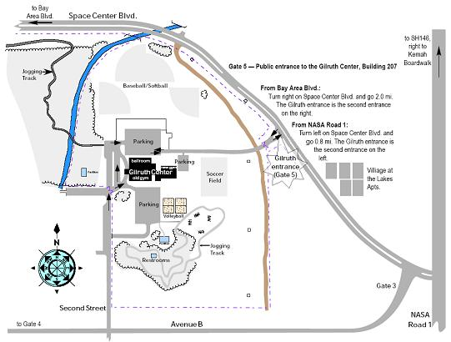
Figure 1. JSC Gate 5 Public Entrance Map
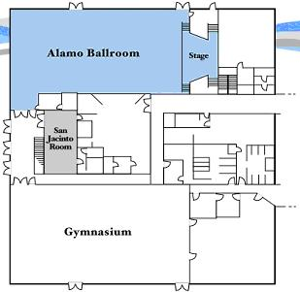
Figure 2. Gilruth Center First Floor
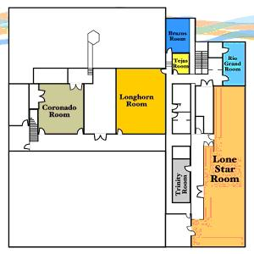
Figure 3. Gilruth Center Second Floor

Symposium Information

Registration
Registration is free for presenters and $10 for attendees and is open all day beginning at 7:45 AM. Advance reservations are recommended but not required. Advance registration is easy to do on the web at www.aiaa-houston.org/ats2008 . The registration desk is located in the hallway leading to the Alamo Ballroom. Registration is paid at the event and not online. There is no additional fee for the buffet lunch – the cost is included in the registration fee. Advance reservations for lunch are required by Thursday, May 1st and can be done online at the registration website listed above.

Special Events
Morning Keynote Speaker:
8:15-8:45 AM, Alamo Ballroom
Keynote Speaker: Mr. Wayne Hale / NASA HQ
“Shuttle/Station Schedule: Transition Plan to Constellation”

Complimentary coffee, bottled water, assorted juices, and breakfast food provided

Lunch, 12:00-12:45 PM

La Vincita Global Buffet
Fettuccini Alfredo with Chicken
Vegetable Lasagna
Selection includes Italian tossed salad and green beans, garlic bread, and tiramisu
Vegetarian plate available upon request

Afternoon Keynote Speakers:
12:45p–1:15 PM, Alamo Ballroom
Clint Dorris / ALTAIR Project
“Constellation ALTAIR Lunar Lander Program”

1:15p–1:45 PM, Alamo Ballroom
Keynote Speaker: Chris Culbert / Lunar Surface Systems Project
“Concepts for Building a Base on the Moon”

Technical Program

Technical Sessions
Three sessions will run in parallel in the morning. Morning sessions start at 9:00 AM and end by noon. Lunch begins at noon followed by the lunch program which begins at 12:45 PM and lasts for about an hour and fifteen minutes. Afternoon sessions start at 2:00 PM and end by 4:00 PM.

The sessions are held in the Gilruth Alamo Ballroom and two meeting rooms on the second floor of the Gilruth Center.

Presentations
Each presentation (except for our Keynote) is allocated 35 minutes plus time for questions and any initial setup up to a total of 50 minutes total time. Session chairs will maintain this pace to ensure that attendees can see presentations according to the posted schedule. Each room will be equipped with a laptop computer and a computer projector.

Keynote Speaker Biographies
Mr. N. Wayne Hale, Jr.
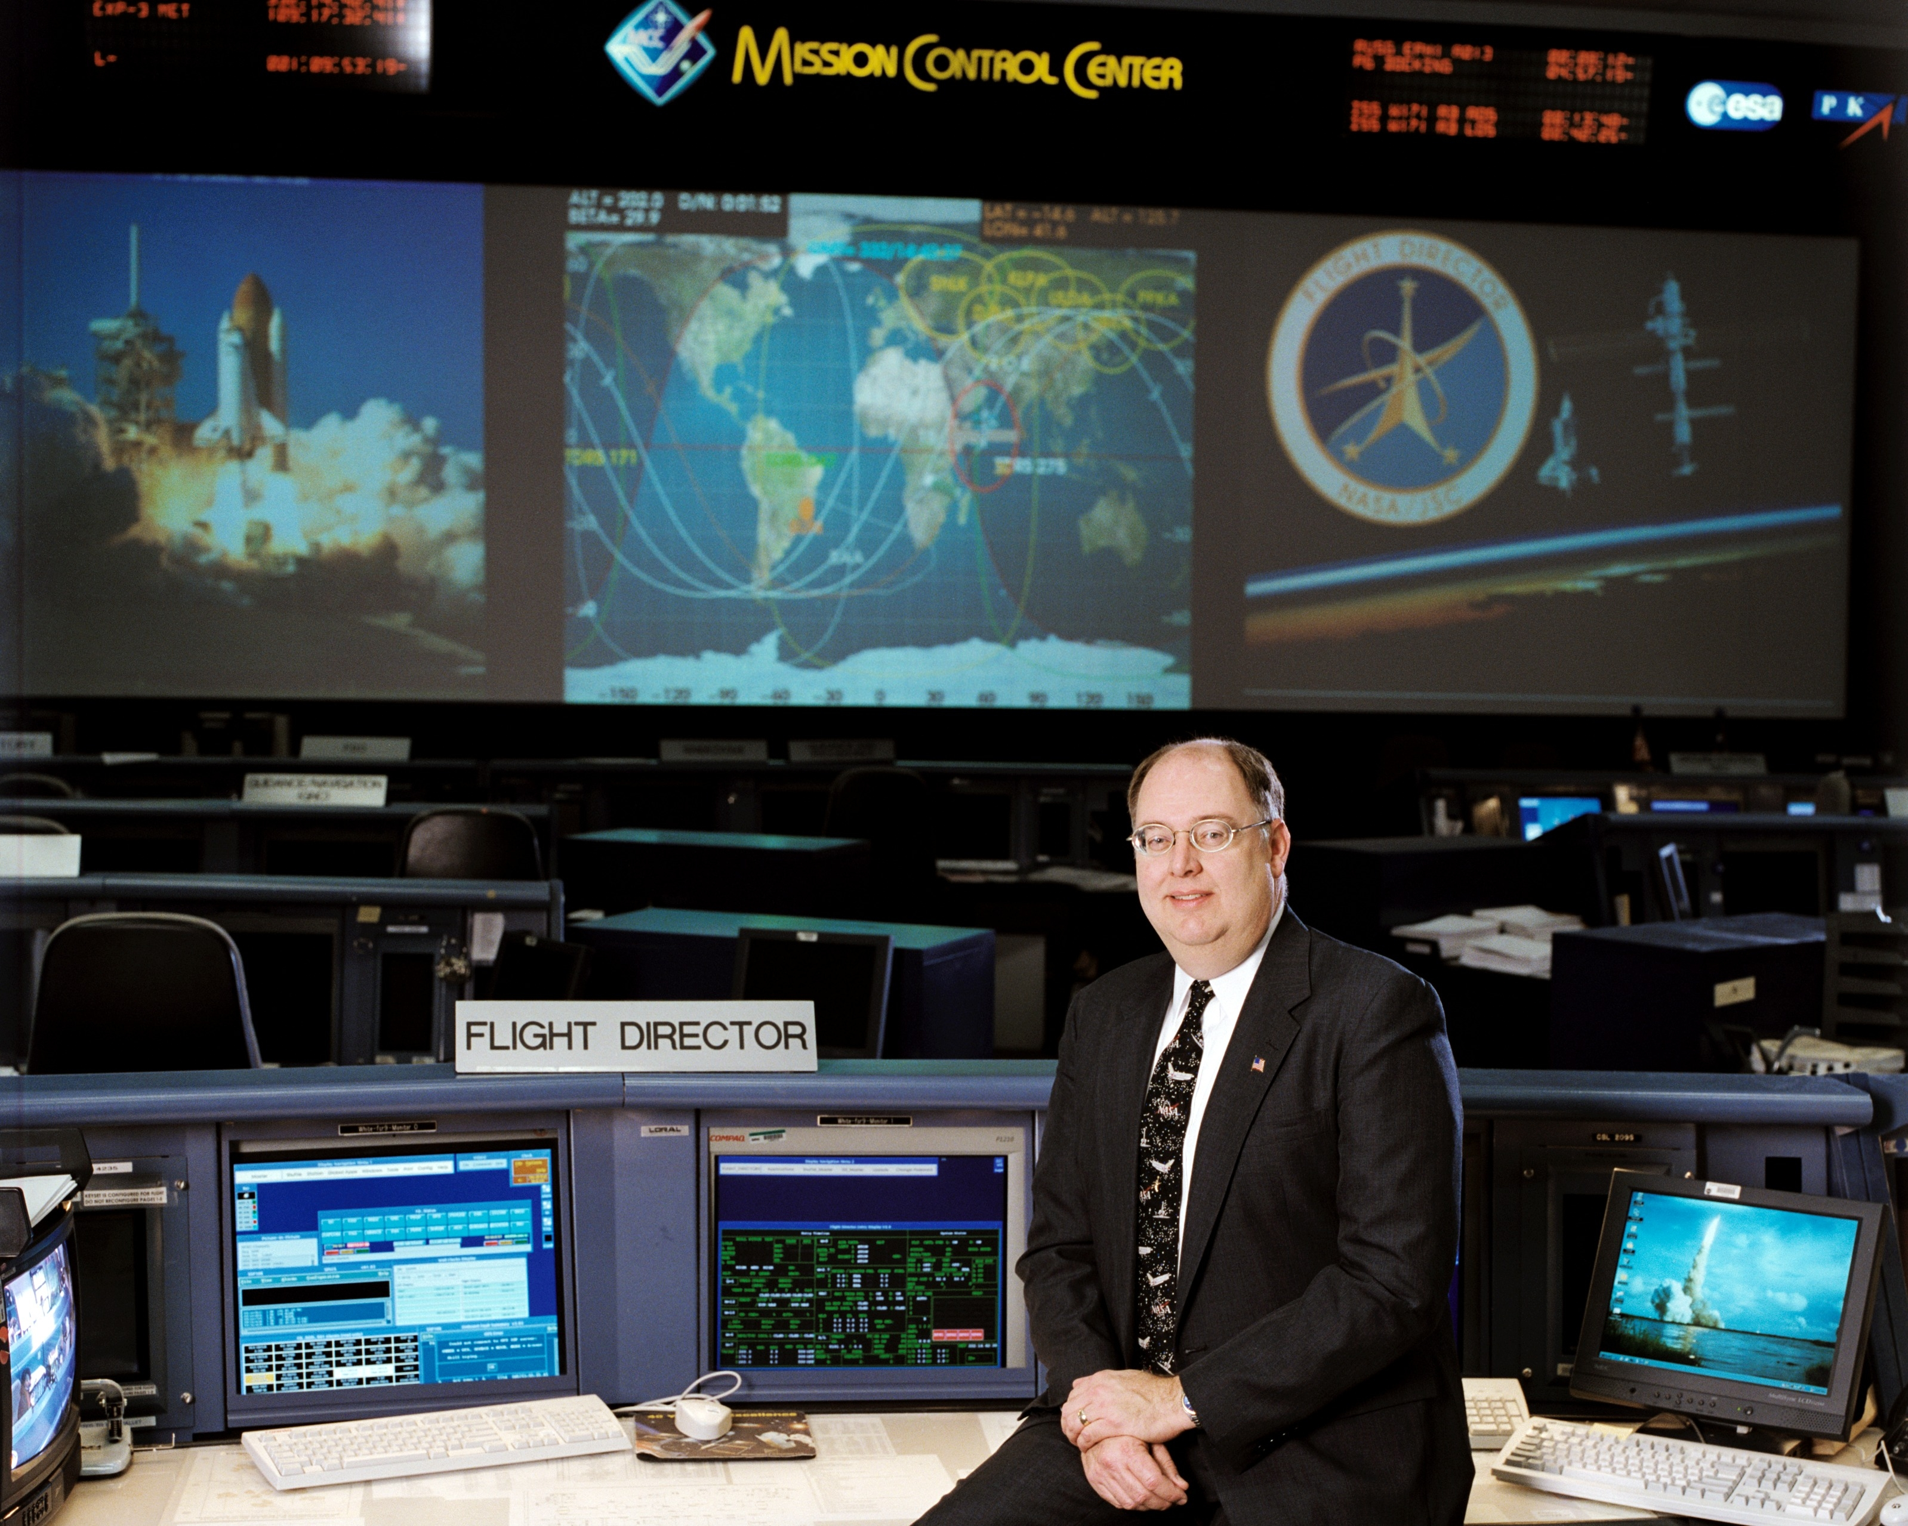
Education:
- Bachelor of Science in Mechanical Engineering, Rice University, 1976;
- Master of Science in Mechanical Engineering, Purdue University, 1978.

Special Honors and Awards:
- NASA Outstanding Leadership Medals 5/2007, 6/2005 8/1999;
- NASA Space Flight Awareness Leadership Award 1/17/02;
- NASA Exceptional Service Medal 4/15/92;
- National Space Club Goddard Memorial Astronautics Engineer of the Year 2007,
- National Air and Space Smithsonian Achievement of the Year 2007.

Current Duties:
Mr. Hale is the Deputy Associate Administrator of Strategic Partnerships, Space Operations Mission Directorate, where he is responsible for coordinating and building partnerships with other agencies, foreign space programs, academic and business entities in relation to space operations.

Previous Positions:
1978-1985: NASA Johnson Space Center, Houston, Texas. Propulsion Systems Section, Flight Control Division of Flight Control Division of Flight Operations Directorate. Propulsion Officer for 10 early Space Shuttle flights.

May to Nov 1985: Head, Integrated Communications Section, Systems Division, Mission Operations Directorate.

Nov 1985 to March 1988: Head, Propulsion Systems Section, Systems Division, Mission Operations Directorate.

March 1988-January 2003: Flight Director for 40 Space Shuttle flights including 28 Ascent/Entry and 3 Lead Flight Director assignments.

2001 to January 2003: Deputy Chief of the Flight Director Office for Shuttle Operations.

February 1, 2003 to July 1, 2003: Space Shuttle Program Launch Integration Manager (KSC).

July 1, 2003 to September 2005: Deputy Manager, Space Shuttle Program.

September 2005 to February 2008: Program Manager, Space Shuttle Program
Mr. Clinton E. Dorris

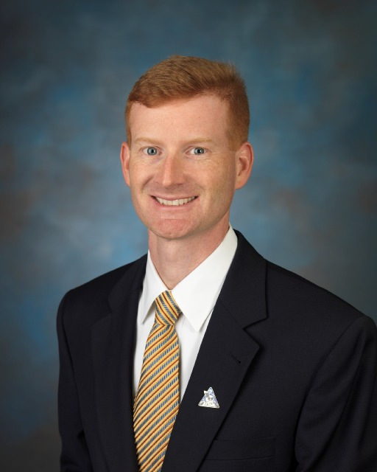
Education:
- Bachelor of Science in Environmental Engineering, Texas A&M University, 1997
- Master of Science in Executive Engineering Management, The University of Texas, Austin, 2003

Honors and Awards:
- Silver Snoopy Award 2001,
- 17 outstanding performance awards 1997 and 2007.

Military Awards:
- Bronze Star Medal, 2 Army Commendation Medals, Good Conduct Medal, 2 Kuwaiti Liberation Medals, 2 Southwest Asia Service Medals, National Defense Medal, Combat Infantryman’s Badge, Army Aviator Badge, Expert Infantryman’s Badge, Parachutist’s Badge, Air Assault Badge, Apache Top-Gun 2001.

Current Duties:
Mr. Dorris is the Deputy Project Manager for NASA’s Lunar Lander (Altair) Project Office located at Johnson Space Center. He is responsible for the design, development, test and evaluation of the next generation human lunar lander, capable to delivering both crew and cargo to the lunar surface for the establishment of a lunar outpost. Mr. Dorris is stationed at the Johnson Space Center in Houston, Texas.

Previous Positions:
2006 to 2007: Most recently, Mr. Dorris was the Deputy Director of NASA’s Advanced Projects Office. Mr. Dorris is stationed at the Johnson Space Center in Houston, Texas.
2005 to 2006: Mr. Dorris served as the Director of the Terrorism Vulnerability Risk Software Products Division for ARES Corporation.
1997 to 2005: Mr. Dorris joined The Boeing Company in 1997 as an engineer performing payload related active thermal analysis for the International Space Station (ISS) and was ultimately promoted to project manager, responsible for a number of ISS-related design, development, test and evaluation (DDT&E) efforts.
1989 to 2003: Mr. Dorris served in the U.S. Army in multiple capacities which included six man team infantryman operations in Desert Storm and an Apache Pilot/Troop Commander

Mr. Chris Culbert

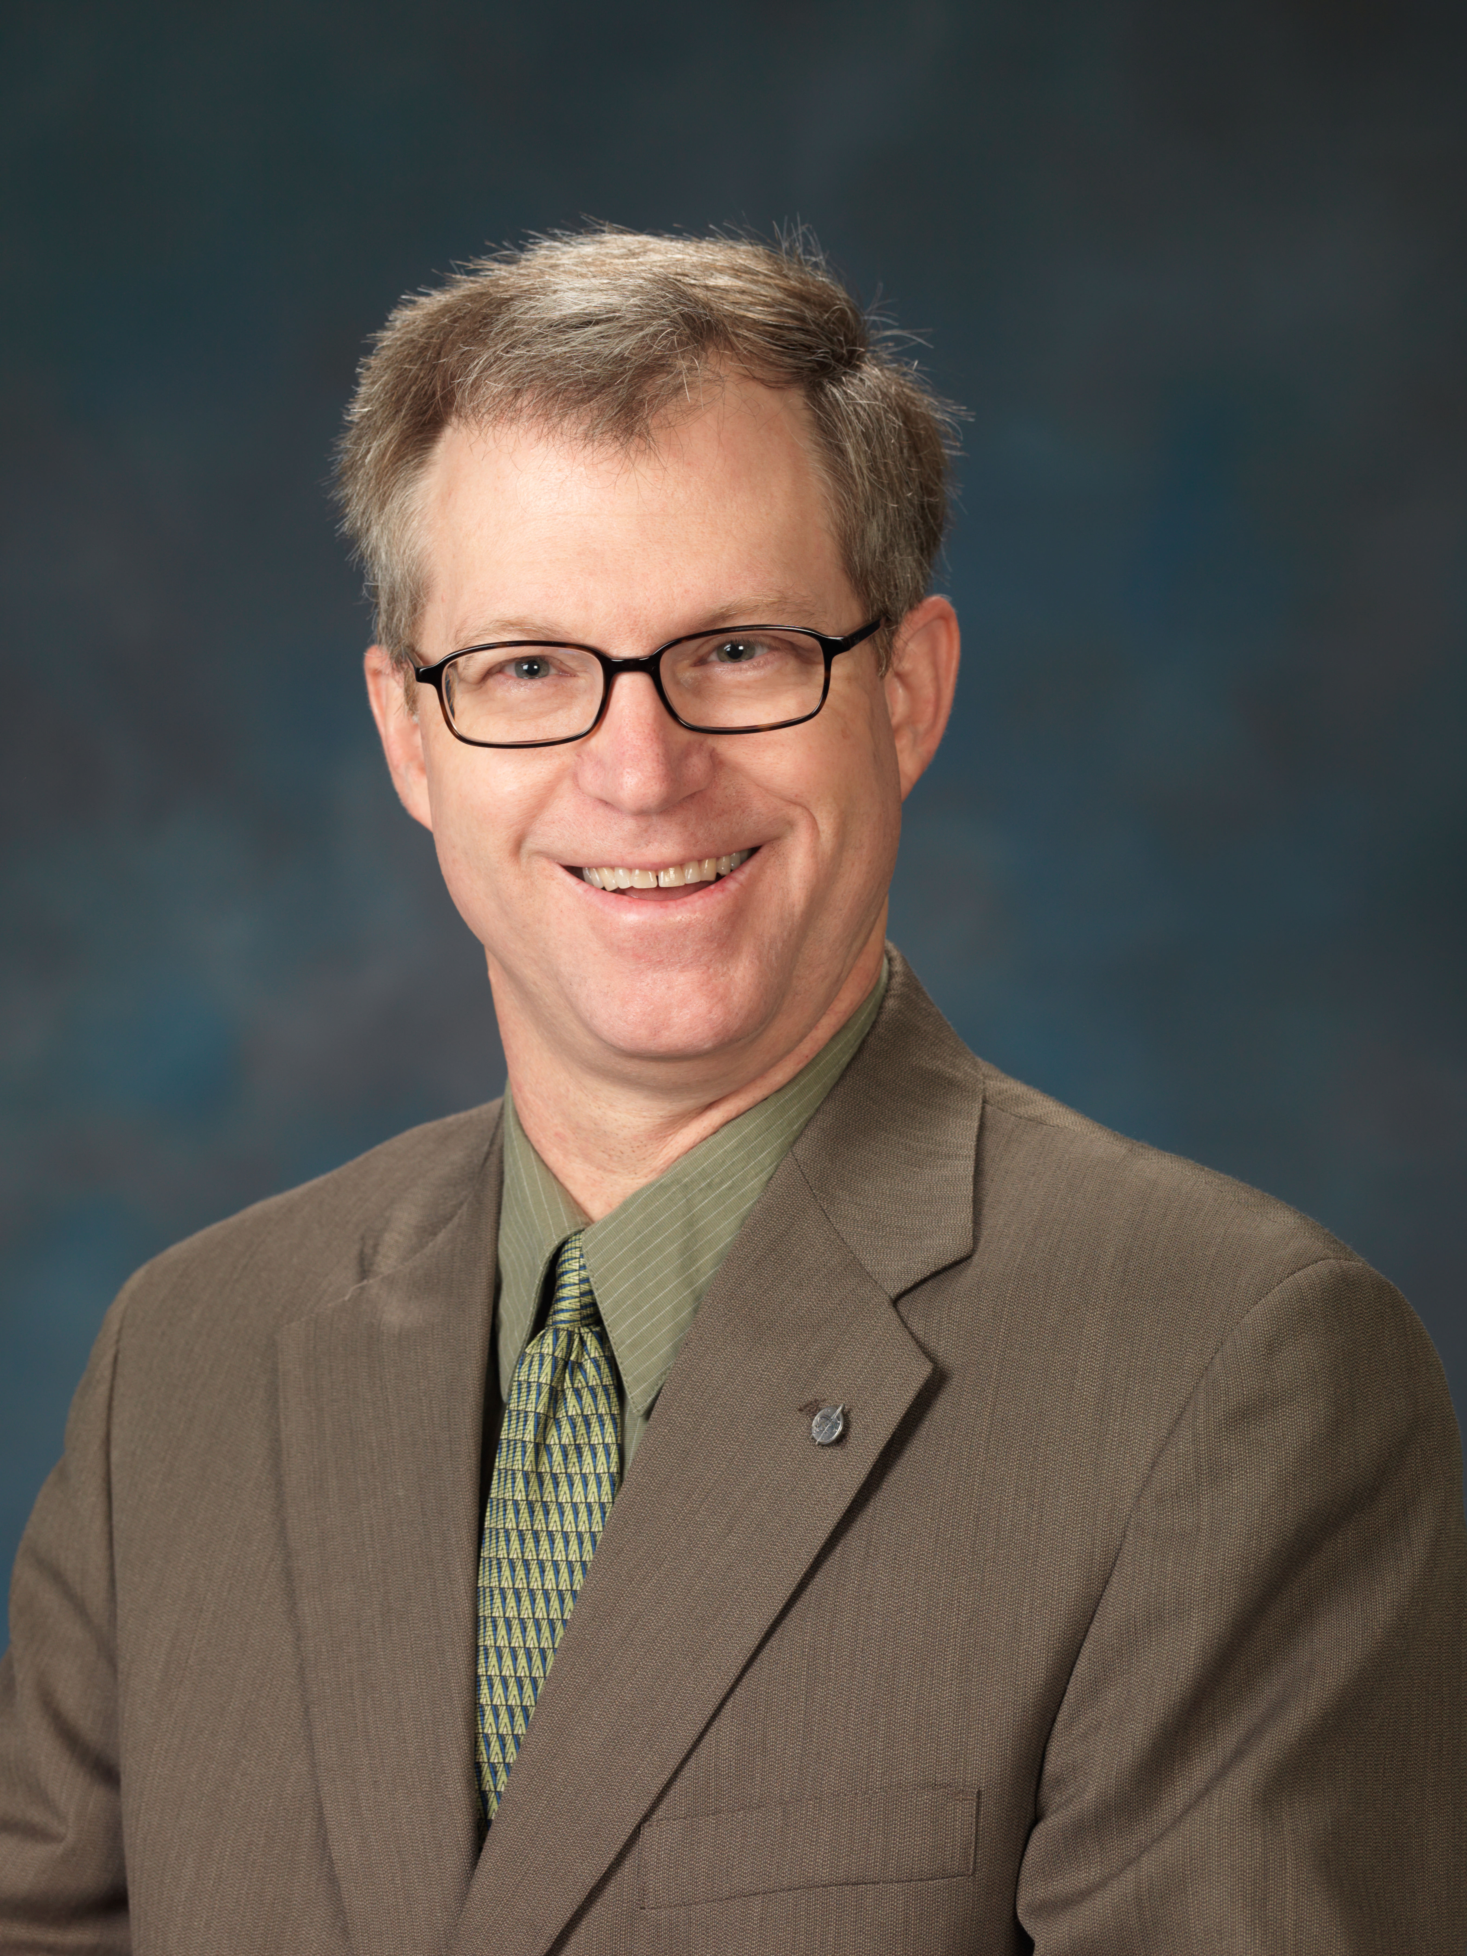
Education:
- B.S. Aerospace Engineering,1981, Univ. of Arizona
- M.S. Space Sciences,1986, Univ. of Houston-Clear Lake
Current Duties:
Mr. Culbert is the Manager of the Lunar Surface Systems Project Office in the Constellation Program at NASA/Johnson Space Center. He is responsible for development of all the systems that will enable humans to establish a habitable Outpost on the Moon after 2020.

Previous Positions:
From 2003 to 2007: Mr. Culbert was the Deputy Division Chief of the Automation, Robotics, and Simulation, Division since 2003. He was integral to all division activities, programmatic, administrative, or technology related and represented the division, directorate, and center in many advanced technology and robotic forums, roadmapping teams, and review panels.

From 2000 to 2003: he was Chief of the Robotic Systems Technology Branch, responsible for development of advanced robotic systems and technologies such as Robonaut, the world’s most advanced humanoid robot.

From 1994 to 1999: Mr. Culbert was in the Information Systems Directorate in a variety of management positions, ending as Chief of the Information Technology Division. He led groups with responsibility for all JSC networks, telephone systems, e-mail systems, client/server applications, and advanced technology for JSC’s information systems.

From 1984 thru 1994:, Mr. Culbert was a member of the Software Technology Branch in the Information Systems Directorate, being promoted to Chief of that branch in 1992. He did extensive work in evaluating and developing expert system tools. He managed numerous projects in such areas as cooperating expert systems, the CLIPS expert system tool, Ada based expert system tools, advanced training technologies such as Intelligent Computer Aided Training (ICAT) and Virtual Reality systems, and applications of advanced automation to elements of the Space Station Freedom.

From 1981 to 1984:, Mr. Culbert was a member of the Mission Planning and Analysis Division (MPAD). While in that group, he served as a flight controller on the High Speed Ground Navigation Console in the Mission Control Center, where he supported a number of Space Shuttle flights.

Technical Session Abstracts

9:00AM-10:0AM
Gilruth, Alamo Ballroom

Author Information
Name: Mr. Robert Hampton
Organization: ARES Corporation
Phone: 281.244.6403
Email: Robert.Hampton-1@nasa.gov

Title: “ISS Lessons Learned: Not Quite Zero, Second Order Effects on a Very Big Spacecrafts”

Abstract
Humans have explored the space environment for just over 50 years, but until recently, a machine as large or as complex as the Intenrational Space Station been never been attempted. Prior experience with small spacecraft led to a comfort level with simplified physics models that could eliminate much of the complicating math, assuming, for instance, that the spacecraft was a point mass, or that there was negligible drag in low earth orbit. The past success of these simplifying assumptions has led to some surprises when the tried-and-true models were used to predict the behavior of a spacecraft the size of a football field, conducting continuous operations year over year. The first 10 years of ISS operations have taught some surprising lessons that can almost always be traced back to previously ignored second-order effects, that can now emerge with enough lenght, mass, or time. In this lecture, we'll explore some of interesting highlights of the things we're learned (or re-learned) about the space environment, and how it interacts with a vehicle that magnifies the second order effects in all three units of measure.

Author Biography:
Graduated from Embry-Riddle Aeronautical University in the Fall of 2004 with a Bachelor of Science degree in Aerospace Engineering. Mr. Hampton began his NASA career in the Summer of 2000 as an intern with Independent Assessment group under the SR&QA contract, and would return again as an intern in 2001 and 2004. Mr. Hampton joined the ARES Corporation as a full time employee in February of 2005 supporting the Program Integration Contract in the ISS Program Safety and Mission Assurance office working in the Operations Safety group. Mr. Hampton transitioned to Vehicle Integrated Performance, Environments, and Resources (VIPER) Team early in 2006 and began work as a systems engineer. He is the systems integration lead for ISS altitude/orbital lifetime and propellant requirements for each stage through the end of life of ISS. He is also responsible for updating the Beta, Attitude, Significant Event Planning Template (BASEPLATE) which is a widely used integration tool for the ISS Program and the Mission Operations Directorate.

9:00AM-10:00AM
Gilruth, Lone Star Room

Author Information
Name: Scott M. Nemeth
Organization: United Space Alliance
Phone: 281-282-3047
Email: scott.m.nemeth@usa-spaceops.com

Title: “Hybrid simulation technology: The next step in the evolution of spaceflight simulation”s

Abstract
For many years, the aerospace community has been building flight simulations as a closed form solution: process inputs, execute the simulation, output results. Hybrid simulation technology extends upon this time proven process by providing a run-time programming interface to the core simulation capabilities. Use of this technology will reduce operational costs in a number of areas, and promote rapid turn-around of tasks by empowering the simulation engineer. The hybrid simulation architecture harnesses modern and mature software technologies that enable organizations to efficiently utilize engineering skills while employing a robust software design that maximizes reuse. In the hybrid software architecture, compiled software objects are extended into a run-time interpreted environment to provide an extremely flexible engineering toolset. Clearly the “run-time” aspect of the hybrid simulation is the key enabling technology that sets it apart from other simulations. The hybrid simulation architecture extensively leverages off open source technologies to provide a simulation interface that requires no input parser development, yet has all the features of a full programming language. For future flight simulations, a balance and optimization of rocket science, computer science and human factors are all necessary for efficient and low cost operations. The hybrid simulation architecture is particularly well suited to balance these areas and support the challenging engineering tasks of future spaceflight operations.

Author Biography:
Scott M. Nemeth is an aerospace engineer at United Space Alliance and has 20 years experience in aerospace and mechanical engineering. He currently supports the Constellation program and Space Shuttle flight operations in ascent/descent trajectory design. Mr. Nemeth holds an Aeronautical and Astronautical Engineering degree from the University of Illinois.
9:00AM-10:00AM
Gilruth, Longhorn Room

Author Information
Name: Steven N. Rader
Organization: NASA
Phone: 281-244-0015
Email: steven.n.rader@nasa.gov

Title: “Overview of the Constellation Command, Control, Communications, and Information (C3I) Architecture”

Abstract
This presentation explains the Constellation Program's new strategic approach for achieving system interoperability and maximizing commonality across a broad range of systems including the Crew Launch Vehicle, the Crew Exploration Vehicle, the launch and mission control centers, space suit systems, lunar landers, and lunar base systems. The architecture includes five technical domains: communications/networks, information architectures, framework, security and command & control (C2). Each domain area has analyzed the adequacy of existing approaches and standards and is prototyping new technology areas. The presentation will include some of the key technology challenges and some of the important technical decisions which have been made so far which affect NASA's long-term approach to addressing interoperability across space systems.

Author Biography:
Steve Rader is the C3I Chief Architect within the Constellation Program's Systems Engineering & Integration Office. Mr. Rader has worked at JSC since 1989 in both Operations and Engineering on Shuttle, ISS, X-38, and Constellation programs focusing on software and communications systems. Mr. Rader holds a Mechanical Engineering degree from Rice University.

10:00AM-11:00AM
Gilruth, Alamo Ballroom

Author Information
Name: Heather M. Rodriguez
Organization: ESCG\Jacobs
Phone: 281-483-2938
Email: heather.m.rodriguez@nasa.gov

Co-author(s): J. C. Liou, ESCG\ERC

Title: “Orbital Debris: Past, Present, and Future”

Abstract
With the first man-made satellite launched in 1957, no one expected the event would be the beginning of a growing environmental issue for the space community today. The combination of almost 5000 launches and 200 on-orbit fragmentations of spacecraft and rocket bodies since then have created an orbital debris issue. Approximately 17,000 objects are currently tracked in orbit by the U.S. Space Surveillance Network (SSN). The majority of these objects are 10 cm (softball size) and larger. There are even more objects smaller in size that cannot be detected by the SSN sensors, yet they present potential threats to operating satellites. To address the debris issue, the space community has developed mitigation measures to limit the growth of the debris population in the future. However, these mitigation measures will not stop the population growth only slow it down. The ongoing space activities and continued on-orbit fragmentation events will require additional efforts to stabilize the future debris populations. This presentation provides a summary of the history of orbital debris, means to measure and characterize the debris populations, an assessment of the current environment, and the challenges for the community to preserve the near-Earth space for future generations.

Author Biography:
Heather M. Rodriguez is currently attending the University of Houston in Houston, Texas working towards her Ph.D. in Space Physics. She received her B.S. in 2004 and M.S. in 2006. In the summer of 2003 she had an internship with the Orbital Debris Program Office at NASA Johnson Space Center then started working full-time May 2005. She plans to write her dissertation from the work in the Orbital Debris Program Office on studies with shape and size of orbital debris classified by their light curves.
10:00AM-11:00AM
Gilruth, Lone Star Room

Author Information
Name: Eduardo Garcia-Llama
Organization: GBTech/EG5
Phone: (281)483.8223
Email: eduardo.g.llama@nasa.gov

Title: “Attitude determination for emergency atmospheric entry with 3-axis accelerometer”

Abstract
This presentation shows an algorithm that, with the use of a 3-axis accelerometer, will be able to determine the angles of attack and sideslip of a capsule-type spacecraft during entry. The algorithm is conceived for emergency situations where no attitude navigation from the primary system is available, and primarily for its use at high altitudes, before the maximum heat rate is reached. Provided that the spacecraft will not attempt a guided entry without nominal navigation, the mission goal will be to attempt a ballistic entry. A ballistic entry requires two phases to be executed in sequence: First, maneuver the capsule to the heat-shield-forward attitude, preferably to the trim attitude; and second, impart a bank rate to null the average lift vector in order to prevent prolonged lift down situations. Since the trim attitude is specified in terms of the angles of attack and sideslip, being able to determine the current attitude in terms of these angles will allow the control system (nominal, backup or manual) to maneuver the vehicle to the trim attitude.

Author Biography:
Master Degree in Physics. I have worked 2 years at the European Space Agency and at the JSC's Flight Mechanics and Trajectory Design Branch since 1999. I have been the On-orbit Guidance Lead for the X-38. I have worked in ESAS and in the CEV-Orion emergency entry mode.
10:00AM-11:00AM
Gilruth, Longhorn Room

Author Information
Name: Chris Ramsay
Organization: NASA Safety and Mission Assurance, Shuttle and Exploration Division
Phone: (281) 483-0717
Email: christopher.m.ramsay@nasa.gov

Title: “SOFTWARE SAFETY: NASA’s Software Safety Standard”

Abstract
NASA relies more and more on software to control, monitor, and verify its safety critical systems, facilities and operations. Since the 1960’s there has hardly been a spacecraft launched that does not have a computer on board that will provide command and control services. There have been recent incidents where software has played a role in high-profile mission failures and hazardous incidents. For example, the Mars Orbiter, Mars Polar Lander, the DART (Demonstration of Autonomous Rendezvous Technology), and MER (Mars Exploration Rover) Spirit anomalies were all caused or contributed to by software. The Mission Control Centers for the Shuttle, ISS, and unmanned programs are highly dependant on software for data displays, analysis, and mission planning.

Despite this growing dependence on software control and monitoring, there has been little to no consistent application of software safety practices and methodology to NASA’s projects with safety critical software. Meanwhile, academia and private industry have been stepping forward with procedures and standards for safety critical systems and software, for example Dr. Nancy Leveson’s book Safeware: System Safety and Computers. The NASA Software Safety Standard, originally published in 1997, was widely ignored due to its complexity and poor organization.

Led by NASA Headquarters Office of Safety and Mission Assurance, the NASA Software Safety Standard has recently undergone a significant update. This new standard provides the procedures and guidelines for evaluating a project for safety criticality and then lays out the minimum project lifecycle requirements to assure the software is created, operated, and maintained in the safest possible manner. This presentation will discuss the new NASA Software Safety Standard, its organization, and key features.

Author Biography:
Mr. Ramsay received a Bachelor of Science in Mathematics, cum laude, from Rhodes College in Memphis, Tennessee in 1980. After college he was hired by NASA and has worked at the Johnson Space Center for the past 28 years. Throughout his NASA career, Mr. Ramsay has had numerous responsibilities with the Space Shuttle Data Processing System hardware and software. These include working as an instructor in the Shuttle Mission Simulator, and as a Space Shuttle Flight Controller. Currently he works in the Shuttle & Exploration Division of the Safety and Mission Assurance Directorate. He is involved with the implementation of Software Safety and Assurance policies within the Space Shuttle and the Constellation Programs. He is also an avid student of NASA History, and frequently lectures on that subject to new employees.
11:00AM-12:00PM
Gilruth, Alamo Ballroom

Author Information
Name: Bill Bastedo
Organization: Booz Allen Hamilton
Phone: 281-280-7103
Email: Bastedo_William@bah.com

Title: “ISS Lessons Learned: Getting Node 1 Ready to Fly”

Abstract
This presentation highlights the first American Flight of the International Space Station (ISS) Program, Node 1. It will provide first-hand insight for what it takes to build and fly spacecraft for human exploration. A number of lessons learned will be presented. This includes discussion of the management of all phases of design, manufacture and test of "Unity" flight hardware/software, on-orbit operations planning, and integration with the Space Shuttle system and interface definition and integration with the first Russian-built FGB element. As the pathfinder for the Program, Bill's team developed the processes that are now being followed by all subsequent ISS missions.

Author Biography:
Bill Bastedo is a Vice President at Booz Allen Hamilton in charge of NASA business across the firm. He received a BS degree in Aerospace Engineering from Notre Dame in 1983 and an MS in Aerospace Engineering in 1985. He has over 22 years of experience in supporting NASA’s human spaceflight programs. Bill began his career at Rockwell International as a member of the Technical Staff, where he provided systems engineering and flight operations planning support to the Phase B studies of the Space Station Freedom Program. In 1986 he joined Booz Allen Hamilton, where he managed a team that supported Systems Engineering activities on the Grumman-led Space Station Engineering & Integration Contract (SSEIC) contract. The primary focus of the team was to define and manage on-orbit assembly sequence analyses. In 1989 Bill accepted a position with NASA as the Chief of the System Engineering Branch of the Space Station Freedom Program Office in Reston, VA. In 1991, he served as the Associate Director of the Payloads Management and Operations Directorate at the NASA Kennedy Space Center (KSC). In this capacity, he managed technical and administrative matters for the Directorate which performed pre-launch processing of Space Shuttle and ELV payloads, Spacelab processing, Space Station pre-launch manufacture, test and launch vehicle integration, management of NASA ELV launch operations and development and maintenance of all related facilities. In 1996, Bill became the Launch Package/Project Manager for the first American Flight of the International Space Station Program. He was responsible for all aspects of the mission. Bill returned to Booz Allen Hamilton in 1999.

11:00AM-12:00PM
Gilruth, Lone Star Ballroom

Author Information
Name: Lesley A. Weitz
Organization: Texas A&M University
Phone: 716-909-9398
Email: lweitz@tamu.edu

Co-author(s): Magdalini Lagoudas, Space Engineering Institute at Texas A&M Univ
John E. Hurtado, Texas A&M University

Title: “The development of an autonomous robotic team for space habitat construction”

Abstract
NASA’s Vision for Space Exploration includes returning manned missions to the moon by 2020 with the goal of looking forward to manned missions to Mars. Extended habitation on the moon or Mars will require a large habitat for eating, sleeping, and conducting experiments. Autonomous robots could be used to assemble a space habitat in preparation for the arrival of a manned mission. The Robotic Space Colonization Team at Texas A&M University has developed a team of robots that perform an autonomous lifting and transportation task, which is just one part
of the autonomous construction of an extra-terrestrial habitat. The team of autonomous robots has the ability to cooperatively lift and transport construction objects to a desired location. This presentation will describe both the theoretical development and the hardware implementation of the autonomous system. Cooperative control laws have been developed to govern the motion of the robot team for different configurations of two differentially-driven robotic platforms. Hardware implementation included the development of several subsystems: an overhead camera system to measure inertial states of the robots, odometry to measure relative states of the robots, a Multi-Measurement Kalman Filter to determine the best state estimates using the camera and odometry measurements, a wireless communications network, and a central-PC that manages the autonomous system. The Robotic Space Colonization Team is a part of the Space Engineering Institute (SEI) at Texas A&M University's Spacecraft Technology Center. The SEI offers undergraduate students an opportunity to work on NASA-sponsored projects related to the space industry. The mission of the Robotic Space Colonization (RSC) Team is to explore autonomous robotic systems to build a space habitat that enables extended human occupation on the moon or Mars.

Author Biography:
Lesley A. Weitz is a PhD student in the Department of Aerospace Engineering at Texas A&M University. Ms. Weitz is the graduate mentor of the Robotic Space Colonization Team. Magdalini Lagoudas is the director of the Space Engineering Institute at Texas A&M University. John E. Hurtado is an Associate Professor in the Department of Aerospace Engineering at Texas A&M University. Dr. Hurtado is the faculty mentor to the Robotic Space Colonization Team.

11:00AM-12:00PM
Gilruth, Longhorn Ballroom

Author Information
Name: Daniel M Deans
Organization: ManTech SRS Technologies
Phone: 3016148690
Email: daniel.m.deans@nasa.gov

Co-author(s): Sean D Carter, ManTech SRS Technologies

Title: “Application of design for reliability, availability, and maintainability (DFRAM) to complex space systems”

Abstract
Complex space systems are engineered using a lifecycle approach that is divided into phases, from pre-concept development through operations and system retirement. These systems have performance requirements levied upon them that require up-front involvement of many specialty engineering disciplines to ensure those requirements are met. One of these disciplines, reliability engineering, must be applied early in the lifecycle, but throughout the lifecycle as well to guarantee that reliability requirements are achieved. Within industry, a general methodology for designing-in reliability, availability, and maintainability using multiple processes and tools has been applied, but the best approach has been to overlay a very intentional, design-centered process onto the system engineering lifecycle to ensure that requirements are allocated to the design, that analyses are performed that drive the design to meet these requirements, that tests are designed that will verify that requirements have been met and that a growth plan is in place once the system has been fielded. This process is sometimes referred to as Design for Reliability, Availability, and Maintainability (DFRAM) and is applied in several industries, including aerospace, petrochemical, and semiconductor. This presentation will detail the DFRAM process and how it has been applied on space system design to generate successful missions, and how it has grown out of a common sense approach to system engineering. Examples of the approach and how it has been key to the mission success of complex space systems will be provided.

Author Biography:
Daniel Deans is Divisional Vice President of ManTech SRS' Assurance Technology Directorate, providing specialty engineering services to several customers including NASA. Dan's career has spanned several industries as a reliability engineer, including the petrochemical, semiconductor, and aerospace industries, and he is passionate about driving reliability via the overall system engineering process. Dan manages a group of approximately 130 engineers at eight CONUS locations.
Sean Carter is a Program Director for ManTech SRS in the Houston Office, and provides engineering support for the NASA Constellation Program System Engineering and Integration office. Sean has been instrumental in developing reliability engineering policy for the CxP and has provided leadership on several key efforts within the program, including launch availability analyses and sea state assessment. Sean has supported NASA JSC for 17 years of his 18 year career and recently was awarded the JSC Center Director's Award for Innovation.
2:00PM-3:00PM
Gilruth, Alamo Ballroom

Author Information
Name: Steven R. King
Organization: Lockheed Martin
Phone: 281-333-6045
Email: steve.king@lmco.com

Title: “An Overview of Orion CEV Mechanisms”

Abstract
Mechanisms are a combination of rigid or resistant bodies, formed and connected so that they move with definite relative motions with respect to one another. They are used in spacecraft to perform a variety of functions by actuating, positioning, opening, closing, moving, rotating, spinning, separating, deploying, switching, and retaining components, parts, and other elements. This presentation will preview the human-rated aerospace mechanisms being developed for the new Orion Crew Exploration Vehicle.

References:
[1] Fusaro, Robert L., ed. "NASA Space Mechanisms Handbook," NASA/TP—1999-206988. NASA Glenn Research Center, Cleveland, OH, July 1999.

Author Biography:
Steve King is an AIAA Associate Fellow and former Houston Section Chair. He is currently the Manager of Lockheed Martin’s Orion CEV Mechanical Engineering Department in Houston. He has almost 23 years of diverse engineering experience associated with human spaceflight including 14 years of project management. His primary experience centers on the design, development, test, and evaluation of aerospace mechanical, structural, and hardware systems for the Space Shuttle, International Space Station (ISS), various Johnson Space Center in-house projects, and concepts/prototypes for the the ISS Crew Return Vehicle (the X-38), Space Launch Initiative, Orbital Space Plane, and Orion CEV projects. Steve earned a BS in Aerospace Engineering from Texas A&M University in 1985 and a Master of Mechanical Engineering from the University of Houston in 1992, and is a Registered Professional Engineer in Texas. He was a NASA Manned Flight Awareness Honoree for STS-30, and received the NASA Astronaut Office's Silver Snoopy Award in 1991 and a Rotary National Award for Space Achievement Foundation Stellar Award in 2003.

3:00PM-3:30PM
Gilruth, Alamo Ballroom

Author Information
Name: Dr. Jared Squire
Organization: Ad Astra Rocket Company
Phone: (281) 526-0514
Email: jared.squire@adastrarocket.com
Co-author(s): Squire, J.P., Chang Díaz, F.R., Carter, M.D., Cassady, L.D., and Glover, T.G.

Title: “High Power VASIMR Performance Measurements”

Abstract
Over the past two years, the Ad Astra Rocket Company has significantly upgraded the capacity of the Variable Specific Impulse Magnetoplasma Rocket (VASIMR) experiment (VX-100) to process high power (75 kW) and mass throughput. The VASIMR system is comprised of three main stages, plasma production using a helicon, acceleration using ion cyclotron heating (ICH), and exhaust into a magnetic nozzle. Power capability of 30 kW has been demonstrated in the plasma source and 50 kW has been coupled into the ICH stage. Efficient plasma production and ion acceleration has been measured using deuterium, neon and argon. Plasma flux measurements are performed using two separate instruments for cross verification. The first is a reciprocating Langmuir probe with a molybdenum tip bias into ion saturation; with the second being a planar tungsten Langmuir 10-probe array also biased into ion saturation. A 70 GHz microwave interferometer in the same axial region is also used to verify consistency of the data. With argon gas, a plasma source performance of less than 100 eV per ion-electron pair is measured. At these conditions, a near 100 % propellant utilization was maintained with an ion flux exceeding 1021/sec, as specified for a 200 kW rocket system. With ICH acceleration, we measure significant ion flow energies exceeding 300 eV with all three gases. Two different designs of gridded retarding potential analyzers (RPA) are used to measure the ion energies for cross verification. Measurements with an impact target and argon propellant verify thrust capability of 2 Newtons from this experiment. Antenna coupling efficiencies are measured at greater than 90%. Measured efficiency parameters are input into a system efficiency model that predicts a thruster total efficiency of approximately 60%. The only uncertainty is the plasma plume and detachment from the magnetic field at several meters from the rocket, since our vacuum chamber was limited in size (5 m³). The project has been moved to a new facility near by the Johnson Space Center with a dramatic increase in vacuum capability (120 m³) to measure plasma plume characteristics. A high power device is nearing completion, VX-200, with a total power capability of 200 kW and flight-like components for an end-to-end efficiency measurement.

Author Biography:
Dr. Jared Squire carried out his physics Ph.D. work at the Massachusetts Institute of Technology, Plasma Science and Fusion Center, in the area of fusion energy research on a tokamak device using high power RF. He completed a two year DOE postdoctoral study at the General Atomics DIII-D tokamak in San Diego, CA. In 1995, Dr. Squire came to the Johnson Space Center to assist Dr. Chang-Diaz in the founding of the Advanced Space Propulsion Laboratory to develop the VASIMR technology.

3:30PM-4:00PM
Gilruth, Alamo Ballroom

Author Information
Name: Tim Glover
Organization: Ad Astra Rocket Company
Phone: 281-526-0516
Email: tim.glover@adastrarocket.com

Title: “Lunar Access with VASIMR”

Abstract
Efficient transfer of vehicles and cargo from low Earth orbit (LEO) to low lunar orbit (LLO) is important to lunar exploration programs. 60% of the vehicle mass initially in LEO must be consumed as propellant to reach LLO, using LOX-LH2 propulsion. Using a solar-electric VASIMR-propelled transfer vehicle, only 18% of the initial mass in LEO is needed for propellant to make the transfer to LLO. This is due to the 5,000 second specific impulse of the VASIMR engine.

We describe the subsystem technologies required to build such a VASIMR-based transfer vehicle. These subsystem technologies include lightweight high-power concentrator solar arrays, lightweight high-efficiency DC-RF power-processing units, high-temperature superconducting magnets, and the cryo-coolers needed to maintain superconducting magnet temperatures and to store cryogenic propellants.
The operations concept for this lunar tug will be outlined. The range of lunar cargo performance possible within the parameter space of transfer time, power level, and cargo mass will be described.

Author Biography:
Dr. Tim Glover did his Rice University PhD research in the JSC Advanced Space Propulsion Laboratory, performing measurements of ion energy distributions and plasma potential in the VASIMR exhaust plume.
These measurements provided the first clear evidence that the ion cyclotron acceleration process at the heart of VASIMR worked well enough to build an efficient thruster.

